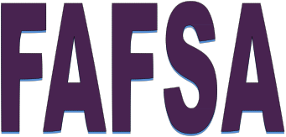

When: Tuesday, Jan. 15th OR Wednesday, Jan. 16th

Time: 6:00 p.m.

Where: Warwick High School, Room C100

Thank you for registering for Warwick’s Financial Aid Workshop, which helps parents of senior college-bound students complete the FAFSA (Free Application for Federal Student Aid). Sonya Mann-McFarlane from the Pennsylvania Higher Education Assistance Agency (PHEAA) will be facilitating the workshop, where participants will complete the filing process. Families will also have the option of submitting an application for the PA State Grant Program at the end of the FAFSA Application.

In order to successfully complete the filing of the FAFSA you will need:

• Social Security Number (parents and students), Driver’s License (students), 2017 W -2
Forms (parents and students),
• 2017 Federal Income Tax Return (parents and students),
• 2017 Untaxed Income Records (welfare, veteran benefits, etc.), Current Bank Statements & Records of Stocks, Bonds & Other Investments,
• Records of Other Untaxed Income Received (ex: Social Security),
• Temporary Assistance to Needy Families (TANF), Business or Farm Records, if applicable,
• Alien Registration Number (if you are not a U.S. Citizen),
• Dependent students will also need both of your parents’ Social Security
Numbers and your parents’ 2017 Income and Financial Records (as listed above).

REGISTERATION IS REQUIRED
Please contact Kathy Miller in the H.S. Counseling Office
at 717-626-3700 ext. 3745.

